ONE SAMPLE TEST

Table 1.0, Summary statistics for tannin concentration on 30 trees(parametric)

|  |  |
| --- | --- |
| Standard Error Mean | 1.31430092 |
| Variance | 51.8216069 |
| Sample size | 30 |

|  |  |  |
| --- | --- | --- |
| Test | Statistic | P value |
| Student’s t | -6.500562 | Pr> |t| <.0001 |
| Sign M | -11 | Pr>= |M| <.0001 |
| Sign Rank S | -207.5 | Pr>= |S| <.0001 |

Table 1.1, Test for Location

|  |  |  |
| --- | --- | --- |
| Test | Statistic | p Value |
| Shapiro-Wilk W | 0.973597 | Pr<W 0.6415 |
| Kurtosis | -0.8829405 | - |
| skewness | -0.1257882 | - |

Table 1.2, Test for Normality

|  |  |
| --- | --- |
| Range | 26.92000 |
| Interquartile Range | 10.50600 |
| median | -9.27300 |
| 25th & 75th percentile | -13.6850 & -3.1790 |

Table 1.3, Summary statistics for tannin concentration on 30 trees(non-parametric)

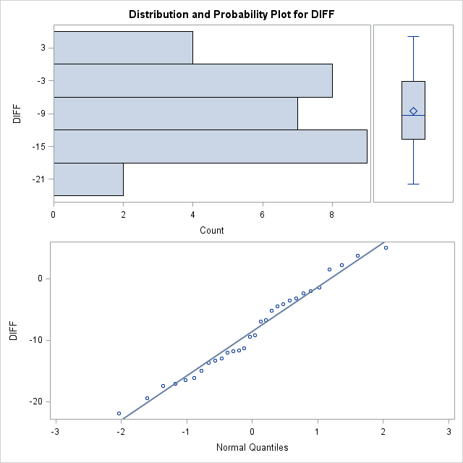

Figure 1.0, Graphical representation of normality

ASSUMPTIONS/CONCLUSIONS

Table 1.0, based on the above output from summary statistics, standard error of the mean gave rough estimate of the intervals in the population mean is likely to fall. This shows that the larger the sample size, the smaller the sample standard error. Like the standard deviation, it can be multiplied by 1.96 to obtain an estimate of where 95% pf the population sample means are expected to fall in the theoretical sampling distribution. Additionally, variance of 51.8216069 indicates that the data somehow spread out from the mean this because variance measures how far set of data spread, zero variance indicate that all data values are identical and non-zero variances are positive.

Table 1.1 and figure 1.0, from the results generate above by these representations there are several assumptions that should be made and met. The normality in our particular case indicates that p value isn’t close to zero that is it doesn’t come close to having a bell-shaped distribution with mean 0 and standard deviation 1. Additionally, measures like skewness and kurtosis was derived to test those assumptions with skewness and kurtosis must fall between ±2 and ±7 respectively. Also, wilk’s test above didn’t have any significance to meet the assumption of normality

Table 1.3, making reference to this table variability in the output was measured by these non-parametric measures. Focusing on Signed Rank S test with p value less than 0.0001 which is a bit close to normality. Conclusion derived from parametric test doesn’t show much difference from the non-parametric test. Upper(75th) and lower (25th) interquartile range values showed there is statistical dispersion in the data set.

Method/Results, the one sample t-test is a statistical procedure used to determine whether a sample of observations could have been generated by a process with a specific mean. The null hypothesis and the alternative hypothesis assumes that some difference exists between the true mean and the comparison value whereas the null hypothesis assumes that no difference exists. The purpose of this test is to determine if the null hypothesis should be rejected given the 30 trees before and after the herbivore attack. For the parametric procedure, the one sample test makes several assumptions. Although t-test are sometimes robust, it always helps to evaluate the degree of deviation from assumptions like the normality, independence and level of measurement.

|  |  |  |  |  |  |  |  |  |  |
| --- | --- | --- | --- | --- | --- | --- | --- | --- | --- |
| Method | Variance | DF | Pr > |t| | food | Mean | N | Std Dev | 95% CL Std Dev | Std Error |
| Pooled | Equal | 25 | 0.0007 | D | 0.8881 | 0.8117 | 0.9644 | 0.1486 | 0.0360 |
| Satterthwaite | Unequal | 10.109 | 0.0111 | L | 1.3544 | 1.0242 | 1.6846 | 0.4615 | 0.1459 |

|  |  |  |  |  |  |  |  |  |  |
| --- | --- | --- | --- | --- | --- | --- | --- | --- | --- |
| Method | Variance | DF | Pr > |t| | food | Mean | N | Std Dev | 95% CL Std Dev | Std Error |
| Pooled | Equal | 25 | 0.0007 | D | 0.8881 | 0.8117 | 0.9644 | 0.1486 | 0.0360 |
| Satterthwaite | Unequal | 10.109 | 0.0111 | L | 1.3544 | 1.0242 | 1.6846 | 0.4615 | 0.1459 |

|  |  |  |  |  |  |  |  |  |  |
| --- | --- | --- | --- | --- | --- | --- | --- | --- | --- |
| Method | Variance | DF | Pr > |t| | food | Mean | 95% CL Mean | Std Dev | 95% CL Std Dev | Std Error |
| Pooled | Equal | 25 | 0.0007 | D | 0.8881 | 0.8117 | 0.9644 | 0.1486 | 0.0360 |
| Satterthwaite | Unequal | 10.109 | 0.0111 | L | 1.3544 | 1.0242 | 1.6846 | 0.4615 | 0.1459 |

|  |  |  |
| --- | --- | --- |
| Test | Statistic | p Value |
| Student's t t | -6.50062 | Pr > |t| <.0001 |
| Sign m | -11 | Pr >= |M| <.0001 |
| Signed Rank s | -207.5 | Pr >= |S| <.0001 |

|  |  |  |
| --- | --- | --- |
| Test | Statistic | p Value |
| Student's t t | -6.50062 | Pr > |t| <.0001 |
| Sign m | -11 | Pr >= |M| <.0001 |
| Signed Rank s | -207.5 | Pr >= |S| <.0001 |
|  |  |  |

|  |  |
| --- | --- |
| Std Error Mean | 1.31430092 |
| Variance | 51.8216069 |
| Coeff Variation | 1.31430092 |
|  |  |

|  |  |
| --- | --- |
| Std Error Mean | 1.31430092 |
| Variance | 51.8216069 |
| Coeff Variation | 1.31430092 |

|  |  |  |
| --- | --- | --- |
| Test | Statistic | p Value |
| Shapiro-Wilk W | 0.973597 | Pr<W 0.6415 |

|  |  |  |
| --- | --- | --- |
| Test | Statistic | p Value |
| Student's t t | -6.50062 | Pr > |t| <.0001 |
| Sign m | -11 | Pr >= |M| <.0001 |
| Signed Rank s | -207.5 | Pr >= |S| <.0001 |

|  |  |  |
| --- | --- | --- |
| Test | Statistic | p Value |
| Shapiro-Wilk W | 0.973597 | Pr<W 0.6415 |

Find the difference divided by the pool